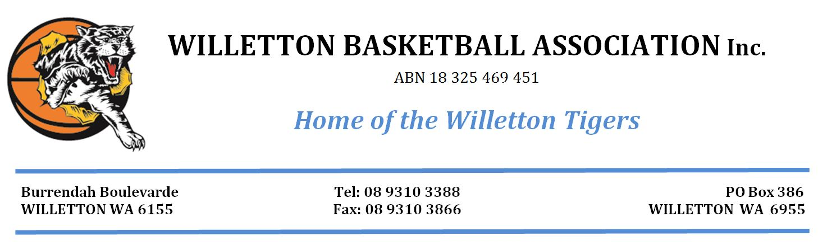Consent form for the use of photographs or video (Parents and children).

Willetton Basketball Association Inc recognises the need to ensure the welfare and safety of all young people taking part in any activity associated with our organisation.
In accordance with our child protection policy we will not permit photographs, video or other images of young people to be taken without the consent of the parents/carers and children. As your child will be taking part in Basketball WA’s WABL competition we would like to ask for your consent to take photographs/videos of the event or activity that may contain images of your child. It is likely that these images may be used as
- a record of the activity or the event
- in a written evaluation report of the activity or event that will be viewed by members of Willetton Basketball Association Inc
- publicity material and social media such as FaceBook or further activities or events on social media, newsletters, websites etc
- future grant applications
The association will take all steps to ensure these images are used solely for the purposes they are intended. If you become aware that these images are being used inappropriately you should inform Willetton Basketball immediately.
We would be grateful if you would return this form to Maria McAdam before the photographs are used.
I ________________________________________(parent/carer) consent to Willetton Basketball Association Inc using photographs or videos of _________________________________________ (Child’s name)
Date:_____________________________

Child’s consent to use of material:

I _____________________________________________ (child) consent to Willetton Basketball Association inc photographing or videoing my involvement in WABL.
Date: _____________________________

